**1.** Implement the **delta training** rule for a two-input linear unit. Train it to fit the target concept

$x_{1}+2x_{2}-2>0$. You must generate your own examples as follows: generate random pairs ${(x}_{1},x_{2})$ and assign them to the positive class if $x_{1}+2x_{2}-2>0$; otherwise assign them to the negative class.

1. Plot the error E as a function of the number of training iterations/epochs.
2. Plot the decision surface after 5, 10, 50, 100 iterations.

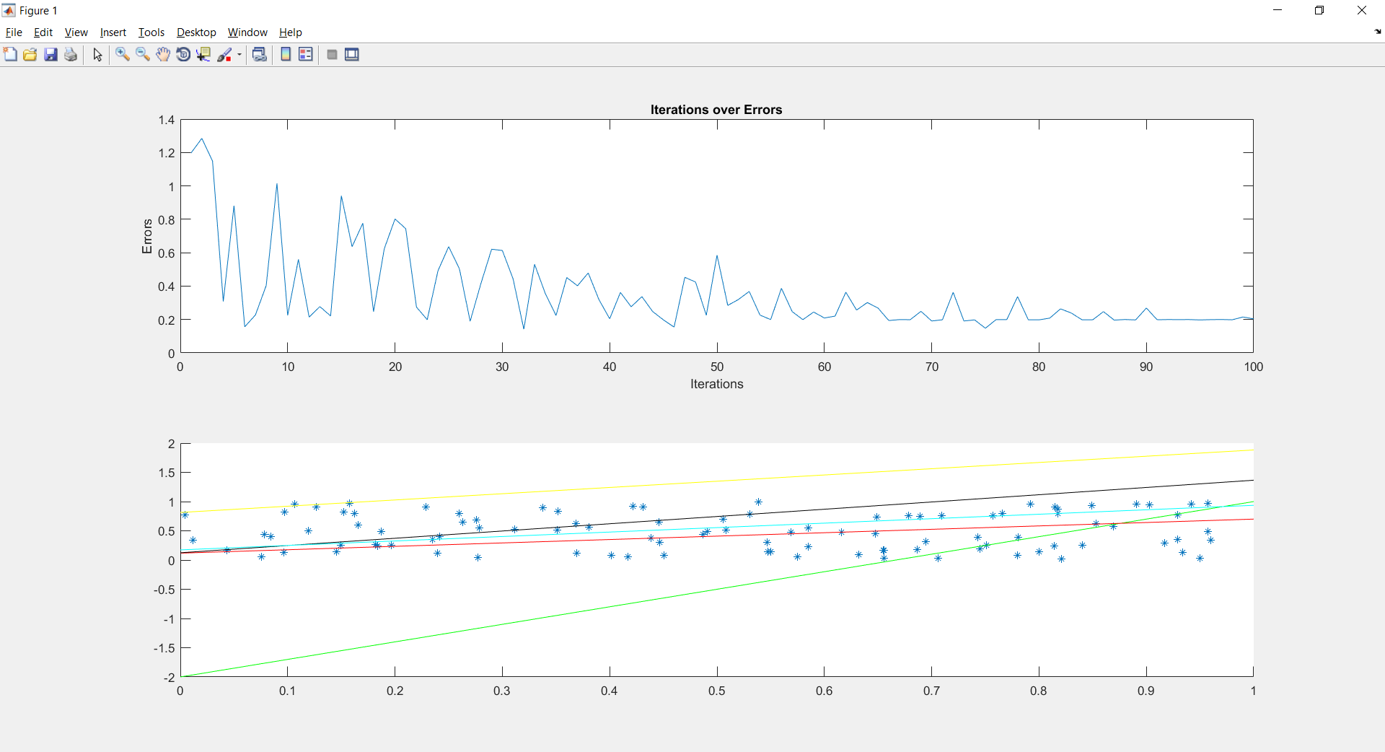

1. Use different learning rates, analyze which works better and explain why.

The below graphs shows the surfaces obtained over different learning rates. We observed that if the learning rate is high, it converges to the lowest number of epochs and vice versa.

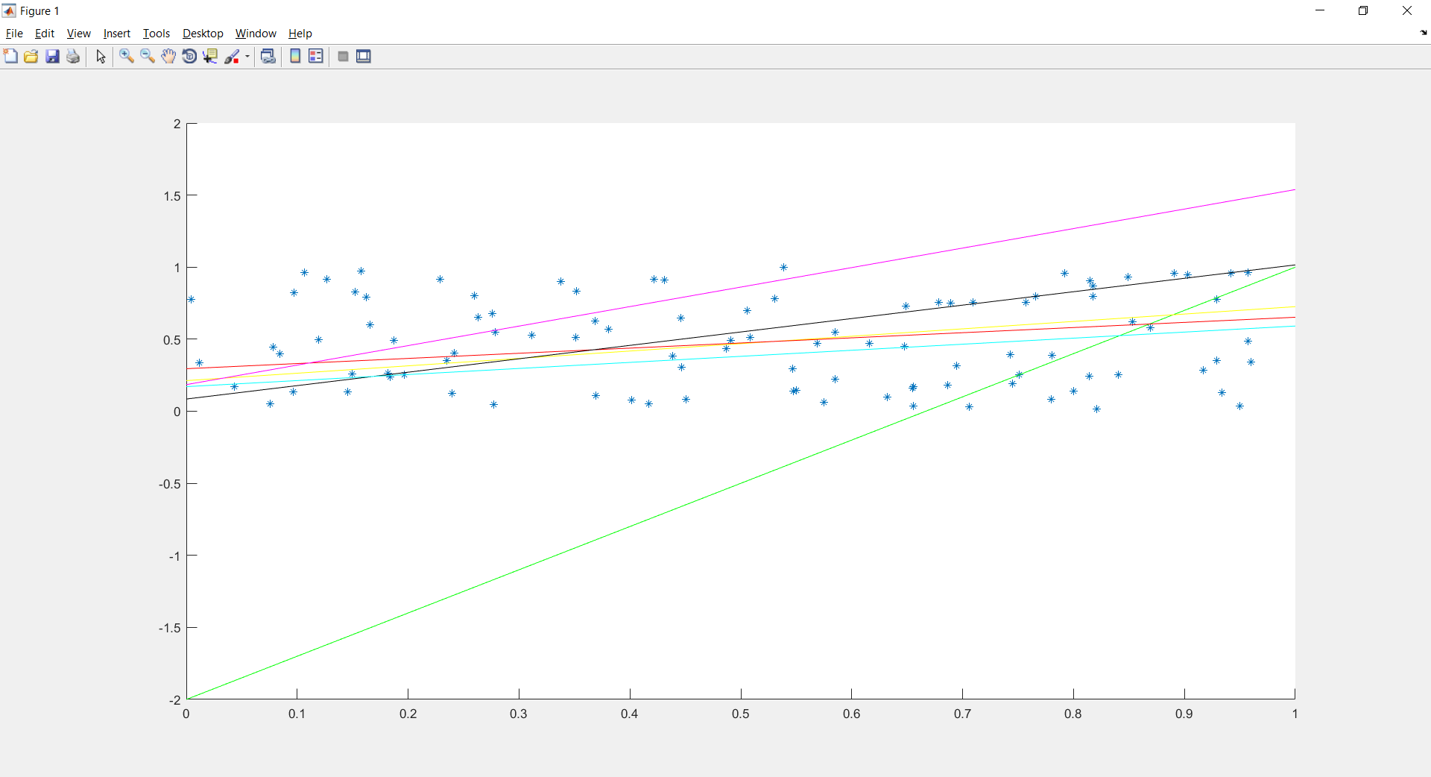

1. Now implement delta rule in an incremental fashion

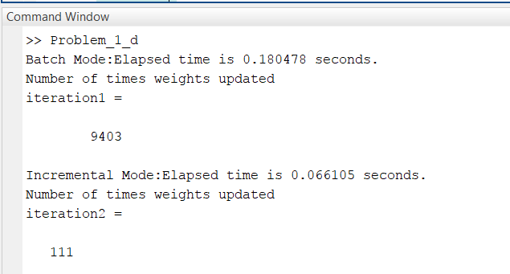

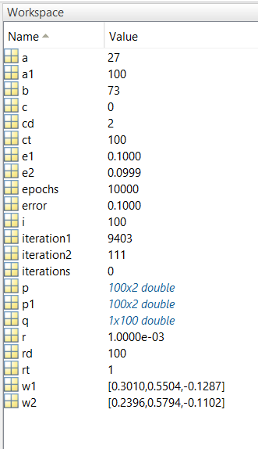

Problem 2: Consider now exactly the same problem as above and implement variable learning rates

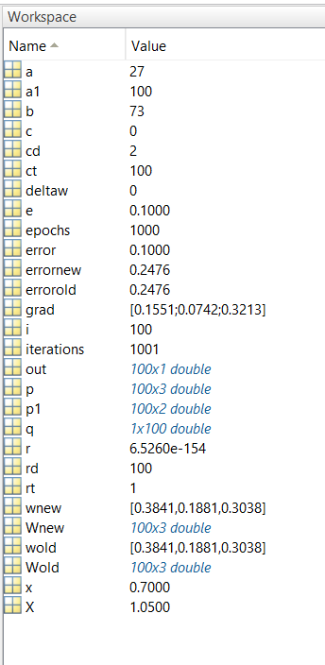

Problem 3: Derive a **gradient descent training rule** for a single unit with output o

